# Experiments with distribution of AAT

### Assumption:

In this report, we assume that for each voxel

## Methods



Fig 1 Diagram of the approach.

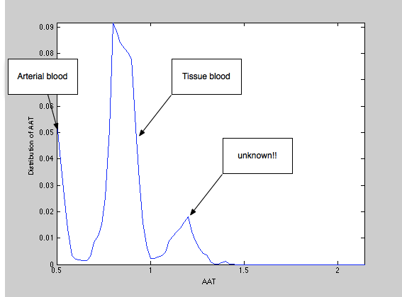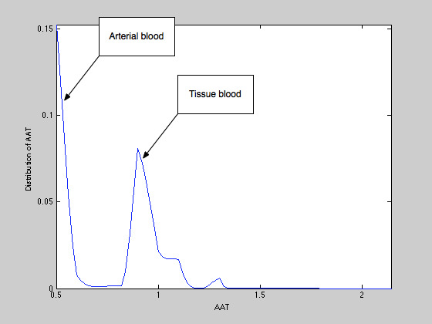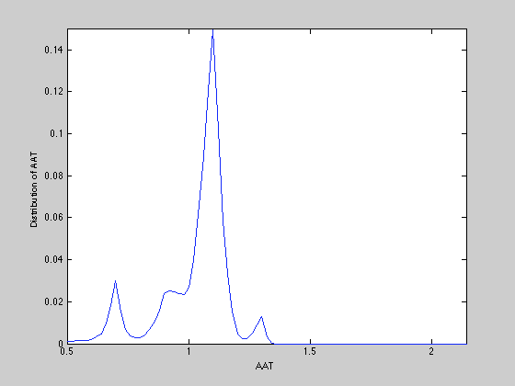

Fig 2 DAAT of three examplar voxels : (left) position 1, (middle) position 2, (right) position 3.

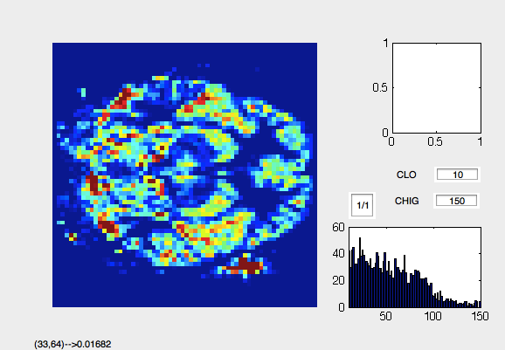 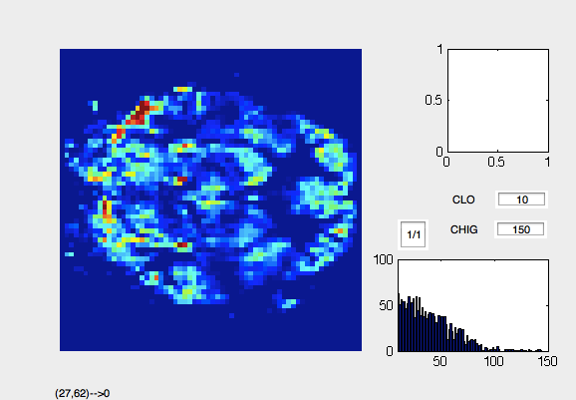

Sum up all AATs Sum up from 5 to (end-10)

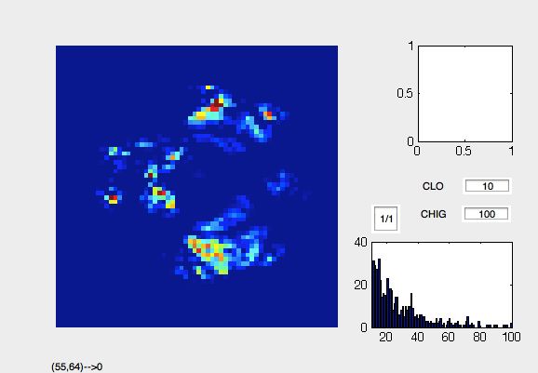

sum up from 1 to 2